Consuming We API in MVC Application.

Create WebApi with EmployeeService (or) Productservice based on the Requirement to perform CRUD operation.

As web api is not having a view to display record in user friendly way. We are using MVC as FrontEnd in this Demo.

With the same solution 🡺 Add New Project🡺 Name it as Consuming_WebaPi_using _MVC_Demo🡺 select a project type(or) template as MVC

Right click on MVC project(Consuming_WebaPi_using _MVC_Demo) 🡺 Manage Nuget packages🡺

Install the below packages using Nuget

1.system.Net .Http

2.Microsoft.ASpNet.WebApiClient

After done the installation 🡺Build Solution

Right click on Models folder🡺Add new Class with the name of Employee

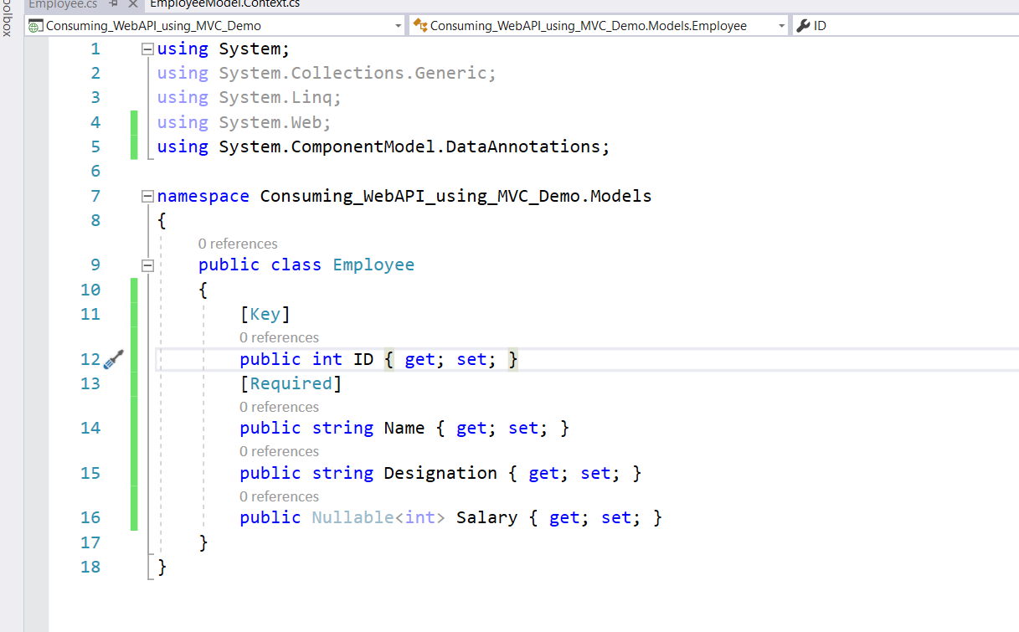

Right click on controllers 🡺 Add new Controller🡺employeeController

using System.Web.Mvc;

using System.Net.Http;

using Consuming_WebAPI_using_MVC_Demo.Models;

using Newtonsoft.Json;

using System.Threading.Tasks;

namespace Consuming_WebAPI_using_MVC_Demo.Controllers

{

public class EmployeeController : Controller

{

// GET: Employee

string BaseURL = "https://localhost:44353/";

public async Task<ActionResult> Index()

{

List<Employee> EmpList = new List<Employee>();

using(var client=new HttpClient())

{

client.BaseAddress = new Uri(BaseURL);

client.DefaultRequestHeaders.Clear();

client.DefaultRequestHeaders.Accept.Add(

new System.Net.Http.Headers.MediaTypeWithQualityHeaderValue("application/json"));

HttpResponseMessage response = await client.GetAsync("api/Employees/FetchEmployees");

if(response.IsSuccessStatusCode)

{

var EmployeeResponse = response.Content.ReadAsStringAsync().Result;

EmpList = JsonConvert.DeserializeObject<List<Employee>>(EmployeeResponse);

}

return View(EmpList);

}

// return View();

}

}

}

